DEVELOP A LEARNING PLAN FOR YOUR EXPERIENTIAL LEARNING PROGRAM
Purpose: The purpose of a program learning plan is threefold:
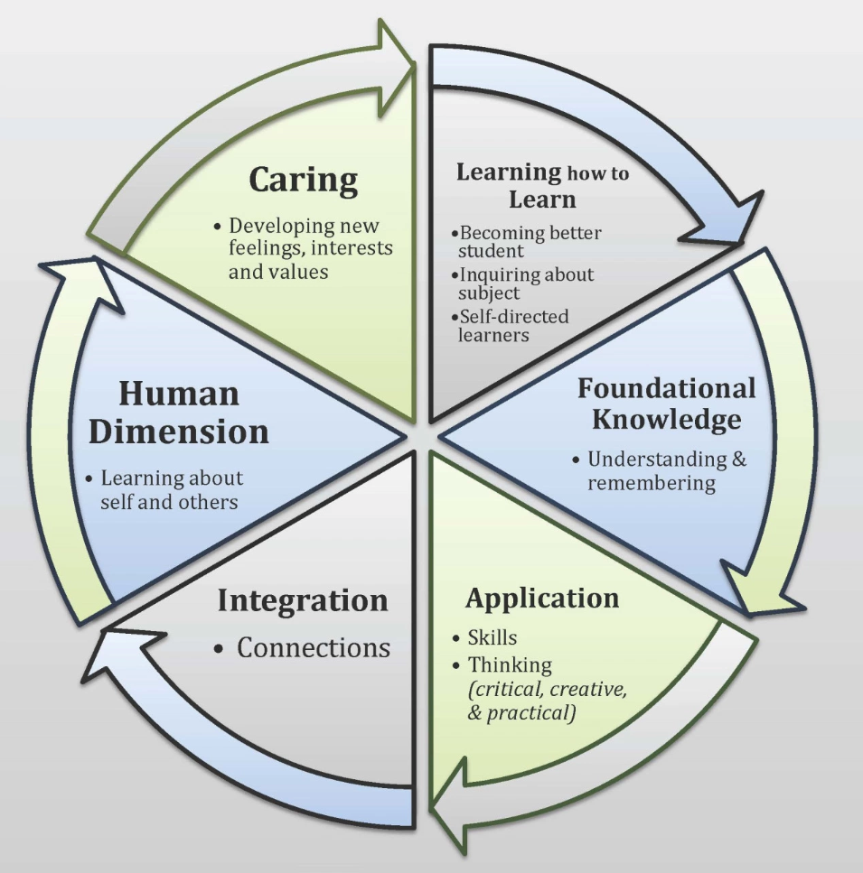
- To focus and articulate the goals for student learning in the experiential learning program;
- To provide a starting point for discussion of specific experiential learning activities in collaboration with students and other stakeholders; and
- To identify appropriate strategies to assess how well students have achieved the learning goals.
Taxonomy of Significant Learning
This Learning Goals Inventory is grounded in Fink’s Taxonomy of Significant Learning:
Integrated Learning Program:
Select one program/course in which you are interested in facilitating and assessing student learning.

_____________________________________________________
(Title of program/course)
Learning Goals Inventory:
Please rate the following 24 items based upon their importance in your experiential learning program. Use the following 5-to-1 rating scale: (5) High; (4) Moderately High; (3) Moderately Low; (2) Low; (1) Not Applicable.
Please use the following prompt when responding to the items below:

As a part of their participation in the student learning experience, students should develop:
Items |  | Scale
FOUNDATIONAL KNOWLEDGE
1. | Knowledge of central facts in the subject area/field of practice | □ 5 □ 4 □ 3 □ 2 □ 1
2. | Knowledge of key terms of the subject area/field of practice | □ 5 □ 4 □ 3 □ 2 □ 1
3. | The ability to translate key ideas from the subject area/field of practice into their own words | □ 5 □ 4 □ 3 □ 2 □ 1
4. | Knowledge of current issues related to the subject area/field of practice | □ 5 □ 4 □ 3 □ 2 □ 1
APPLICATION OF KNOWLEDGE (Transferable skills)
5. | Communication skills | □ 5 □ 4 □ 3 □ 2 □ 1
6. | Technology skills | □ 5 □ 4 □ 3 □ 2 □ 1
7. | Critical thinking skills | □ 5 □ 4 □ 3 □ 2 □ 1
8. | Problem solving skills | □ 5 □ 4 □ 3 □ 2 □ 1
INTEGRATION OF KNOWLEDGE
9. | The ability to connect academic learning with community/workplace experience | □ 5 □ 4 □ 3 □ 2 □ 1
10. | The ability to test new ideas in a real-world environment | □ 5 □ 4 □ 3 □ 2 □ 1
11. | To be able to compare different aspects of community/workplace practice | □ 5 □ 4 □ 3 □ 2 □ 1
12. | To be able to connect learning to career preparation and planning | □ 5 □ 4 □ 3 □ 2 □ 1
HUMAN DIMENSION
13. | Empathy for others | □ 5 □ 4 □ 3 □ 2 □ 1
14. | Respect for others | □ 5 □ 4 □ 3 □ 2 □ 1
15. | Interpersonal skills | □ 5 □ 4 □ 3 □ 2 □ 1
16. | The ability to work productively with others | □ 5 □ 4 □ 3 □ 2 □ 1
CARING
17. | An appreciation of diverse perspectives related to the field of practice | □ 5 □ 4 □ 3 □ 2 □ 1
18. | A commitment to others | □ 5 □ 4 □ 3 □ 2 □ 1
19. | Informed concern about current issues in the field of practice | □ 5 □ 4 □ 3 □ 2 □ 1
20. | The intention to make informed ethical choices | □ 5 □ 4 □ 3 □ 2 □ 1
LEARNING HOW TO LEARN
21. | Knowledge about themselves as learners and employees | □ 5 □ 4 □ 3 □ 2 □ 1
22. | The ability to follow directions/instructions | □ 5 □ 4 □ 3 □ 2 □ 1
23. | The ability to organize and use time effectively | □ 5 □ 4 □ 3 □ 2 □ 1
24. | The ability to self-assess performance | □ 5 □ 4 □ 3 □ 2 □ 1
Scoring
Record the total scores in each subsection of the items above and rate from 1 – 6 based on the highest (1) to lowest (6) total scores.
Domain | Score | Rank | Domain | Score | Rank
FOUNDATIONAL KNOWLEDGE |  |  | HUMAN DIMENSION
APPLICATION OF KNOWLEDGE |  |  | CARING
INTEGRATION OF KNOWLEDGE |  |  | LEARNING HOW TO LEARN

What does a High Score (>12) Suggest about my Experiential Learning Program?
FOUNDATIONAL KNOWLEDGE | Your ratings suggest that you place a high value on students developing the ability to remember and understand certain concepts and facts.
APPLICATION OF KNOWLEDGE | Your ratings suggest that you place a high value on students developing transferable skills and the ability to apply what they have learned in practice.
INTEGRATION OF KNOWLEDGE | Your ratings suggest that you place a high value on students developing the ability to integrate information and demonstrate connections between concepts, people, and different realms of life.
HUMAN DIMENSION | Your ratings suggest that you place a high value on students learning about themselves and others and how human interact.
CARING | Your ratings suggest that you place a high value on students learning to care about others, their WIL experience, and the subject matter/field of practice.
LEARNING HOW TO LEARN | Your ratings suggest that you place a high value on students learning to learn.

Turning Learning Goals into a Learning Plan
Using your top ranked learning domains, identify 3 – 5 specific learning outcomes for your experiential learning program. If you have a few domains that are ranked noticeably higher than the others then you may choose to identify more than one specific learning outcome for that domain. For each specific learning outcome you identify, you are asked to identify potential learning activities to be completed by the student in the experiential learning experience, available resources to support the student learning, and relevant assessment techniques.

Experiential Learning Plan – For Faculty/Staff
Domain | Learning Outcome  (What will the students learn?) | Learning Activities  (How will this be learned?) | Resources  (What supports are available?) | Assessment  (How will I know the students are successful?)
Foundational knowledge | By the end of the experience students will understand key strategies in prescribing exercise for persons with diverse abilities | - Observe adapted exercise sessions  - Develop exercise plans  - Run exercise sessions for children with developmental disabilities | - Weekly feedback meetings with mentor  - Readings  - Opportunities for observation  - Template exercise plans | - Final mentor evaluation of student performance  - Student’s guided case notes  - Term test
1)

2)

3)

Domain | Learning Outcome  (What will the students learn?) | Learning Activities  (How will this be learned?) | Resources  (What supports are available?) | Assessment  (How will I know the students are successful?)
4)

5)

6)

You are encouraged to share your learning plan with other stakeholders (e.g., students and community partners) and return to it frequently!

